Housing Data

Murrumbeena Primary School Enrolment Zone
The designated neighbourhood boundary for Murrumbeena Primary School covers an area of approximately 2.4 km², situated primarily within the suburb of Murrumbeena with slight overlap into neighbouring corridors.
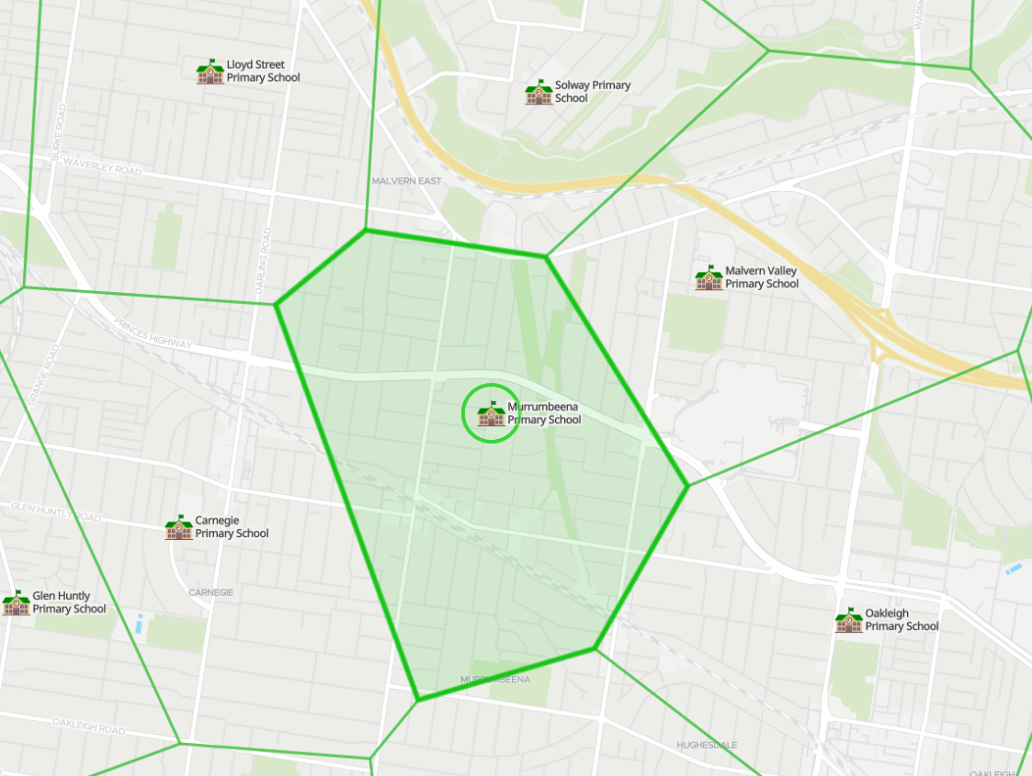

Housing & Apartment Breakdown
The enrolment zone is closely aligned with the Murrumbeena SA2 / suburb statistical boundary. Based on ABS Census and local housing stock data, the dwelling breakdown is distributed:
Type | Share | Distribution
Separate Houses (Detached) | ~48% – 50% | Predominantly classic California bungalows, post-war, and renovated family homes on residential streets.
Flats / Apartments / Units | ~24% – 26% | Concentrated around the Murrumbeena Railway Station / Neerim Road activity centre, Poath Road, and along the Dandenong Road corridor.
Semi-Detached / Townhouses | ~24% – 26% | Subdivision developments, dual-occupancy builds, and modern townhouse infill across suburban blocks.

Summary
- Pure Apartments & Flats: ~25% of the total dwelling.
- Apartments + Townhouses/Units: 50% to 52% of all residential properties in the catchment, with new residential planning approvals trending heavily towards townhouses and multi-unit developments.

